Contents

Part A 2

Part B 3

Introduction: 3

Calculations 4

Results 4

Simulation 6

Hardware implementation 10

Conclusions 14

# Part A

|  |  |  |
| --- | --- | --- |
| 1 | Name of your college | Thapar university |
| 2 | Team Number | 140 |
| 3 | Name, Semester and Branch of the Participants | 1.)Amit Ranjan 5th Semester Electrical  2.)Deepender Singla 5th Sem, Electrical  3.)Gursimran singh 5th sem , C.S.E |
| 4 | Name, contact number and email ID of mentor | Mr.M.D singh  Mob:9815605616  Email:mdsingh@thapar.edu |
| 5 | Problem Statement ( A, B, C or D) | B |
| 6 | CMT ID | 76 |
| 7 | Simulation software you have used | TINA |

# Part B

## Introduction:

An astable multivibrator is a regenerative circuit consisting of two amplifying stages connected in a positive feedback loop by two capacitive-resistive coupling networks. The amplifying elements may be junction or field-effect transistors, vacuum tubes, operational amplifiers or other types of amplifier

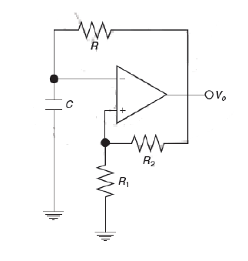

This is the block diagram from TINA simulation software

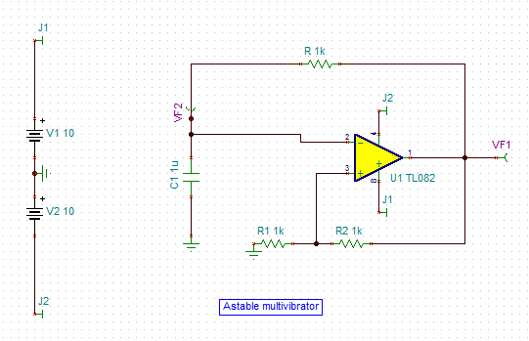

### Calculations

The time period of the square waveform generated by the astable multivibrator is

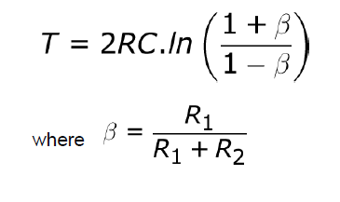

Peak amplitude of triangular wave Vc generated by the astable multivibrator (across capacitor C) is given by ::



### Results

**What was the value of R for maximum frequency of oscillation?**

Two Resistor of 2.2K and 1k in parallel .

Equivalent Resistance = 0. 6875K .

**What was the value of C for maximum frequency of oscillation?**

C=10nf

**What was the value of R for minimum frequency of oscillation?**

R=10k

**What was the value of C for minimum frequency of oscillation?**

C=0.1uf

**What was the theoretical value of highest frequency of oscillation?**

267.54 khz

**What was the theoretical value of the lowest frequency of oscillation?**

164.47 Hz

**What was the peak value of capacitor voltage for maximum frequency of operation?**

1.42 V

**What was the peak value of capacitor voltage for minimum frequency of operation?**

8.52 V

### Simulation

**Plot the transient response (plot of the Vo and Vc as a function of time) for maximum value of frequency of oscillation?**



Vo versus time



Vc versus time



Vo and Vc versus time

**Plot the transient response (plot of the Vo and Vc as a function of time) for minimum value of frequency of oscillation?**



Vo versus time



Vc versus time



**What is the peak value of voltage Vp across the capacitor in cases above?**

In maximum case:2.305 volt  
In minimum case:7.56 volt

**In Figure 1, lift R1 to +5V potential (connect R1 to +5V instead of ground). What happens to the astable action and highest frequency of the multivibrator? Submit the readings and also the transient response?**

Response is not symmetric , and frequency has decreased , Rise time is still the same.

Offset Obtained is 5.33microseconds.



Vo versus time

Readings New Frequency:86.5Khz

### Hardware implementation

Build your circuit using ASLKv2010 Starter Kit for highest possible frequency and lowest possible frequency. Take the picture of the set up and include it in the report.

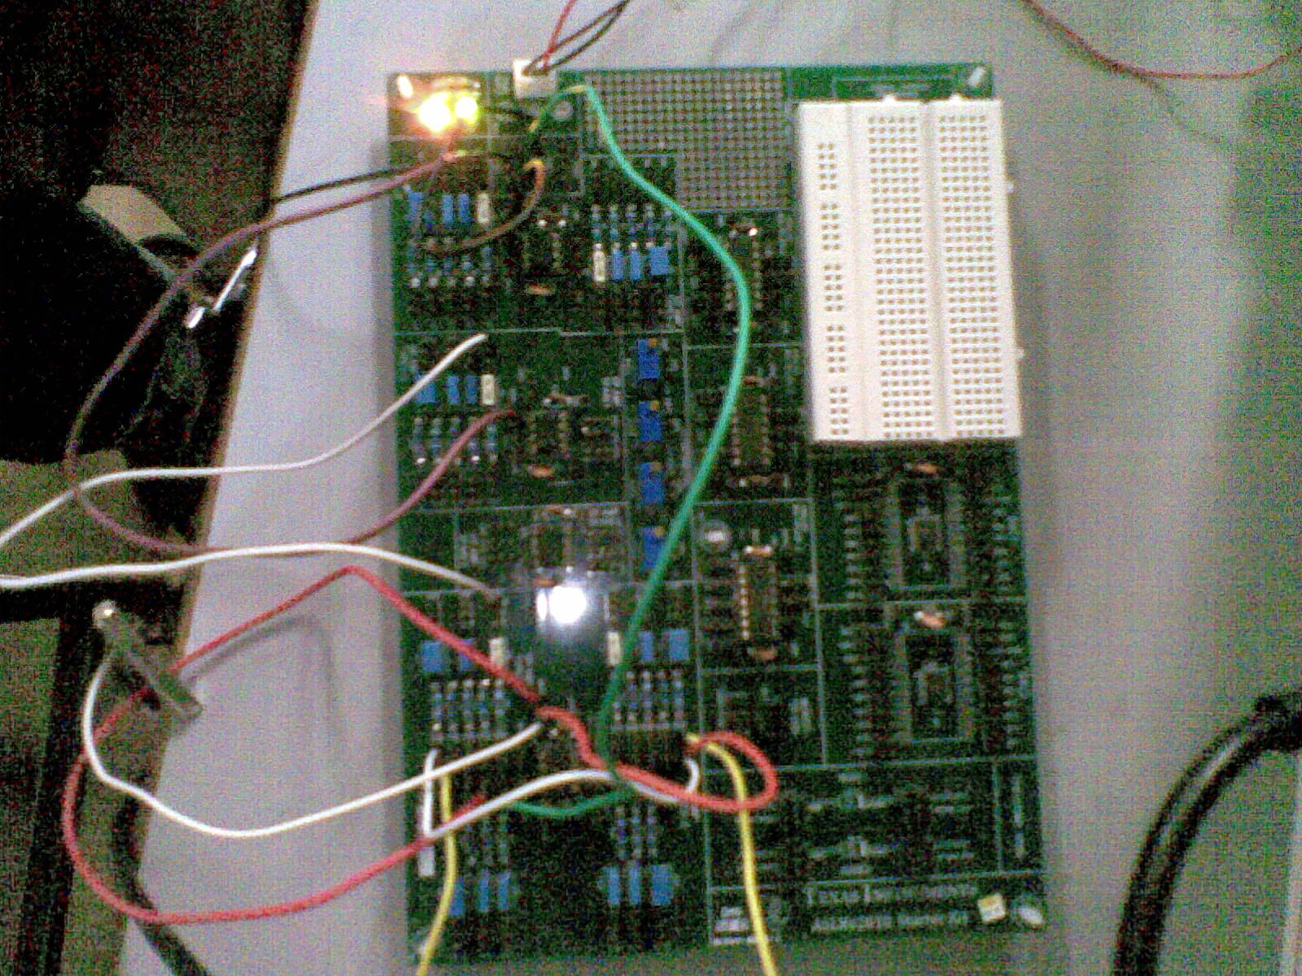

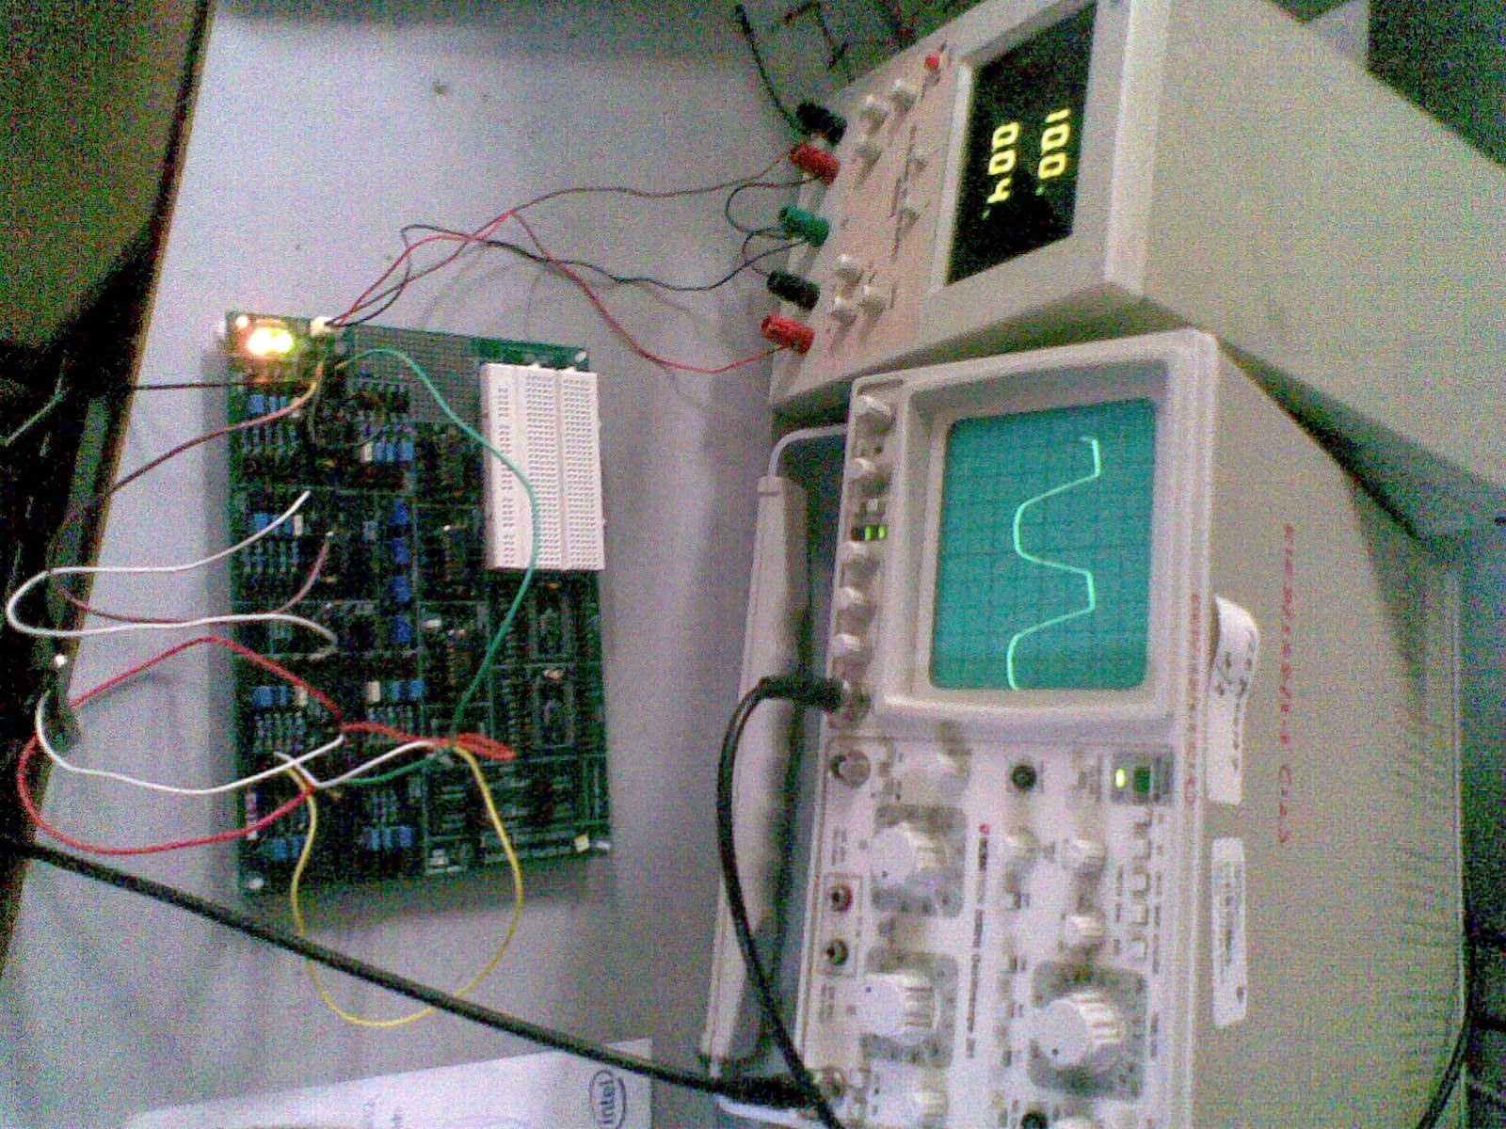

Obtain the transient plots using the CRO and include a snapshot.

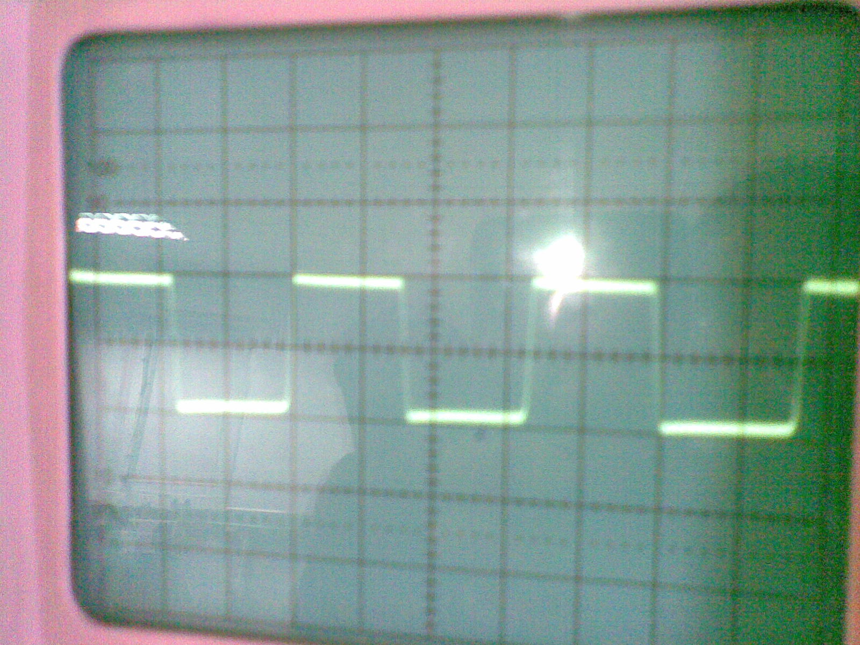

Maximum Frequency plot

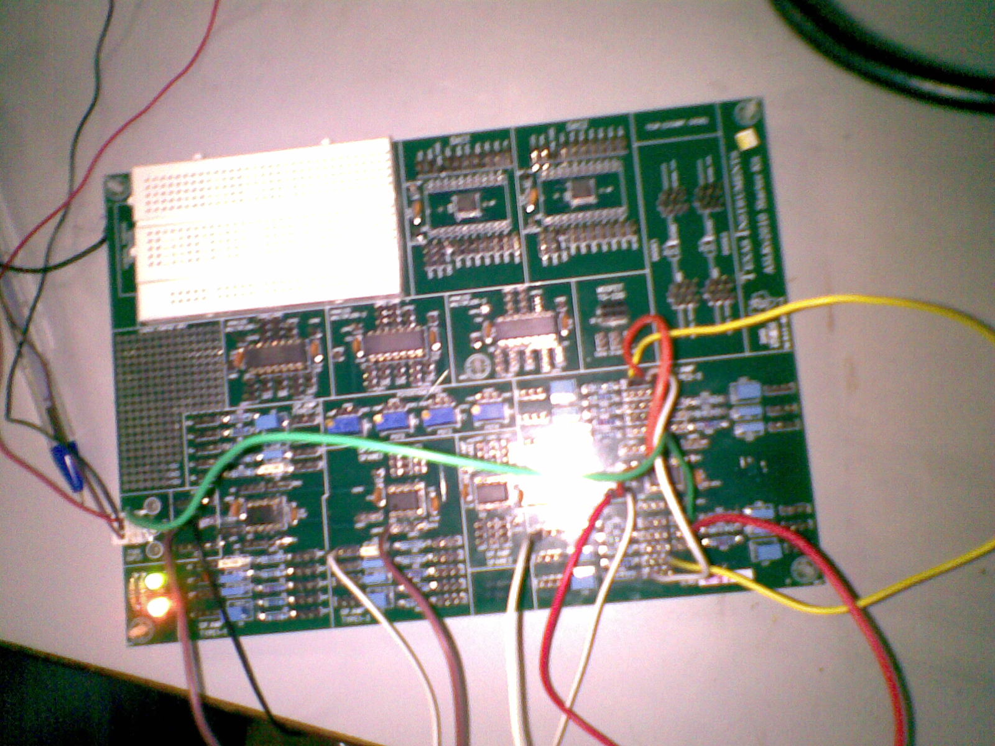

Minimum frequency setup

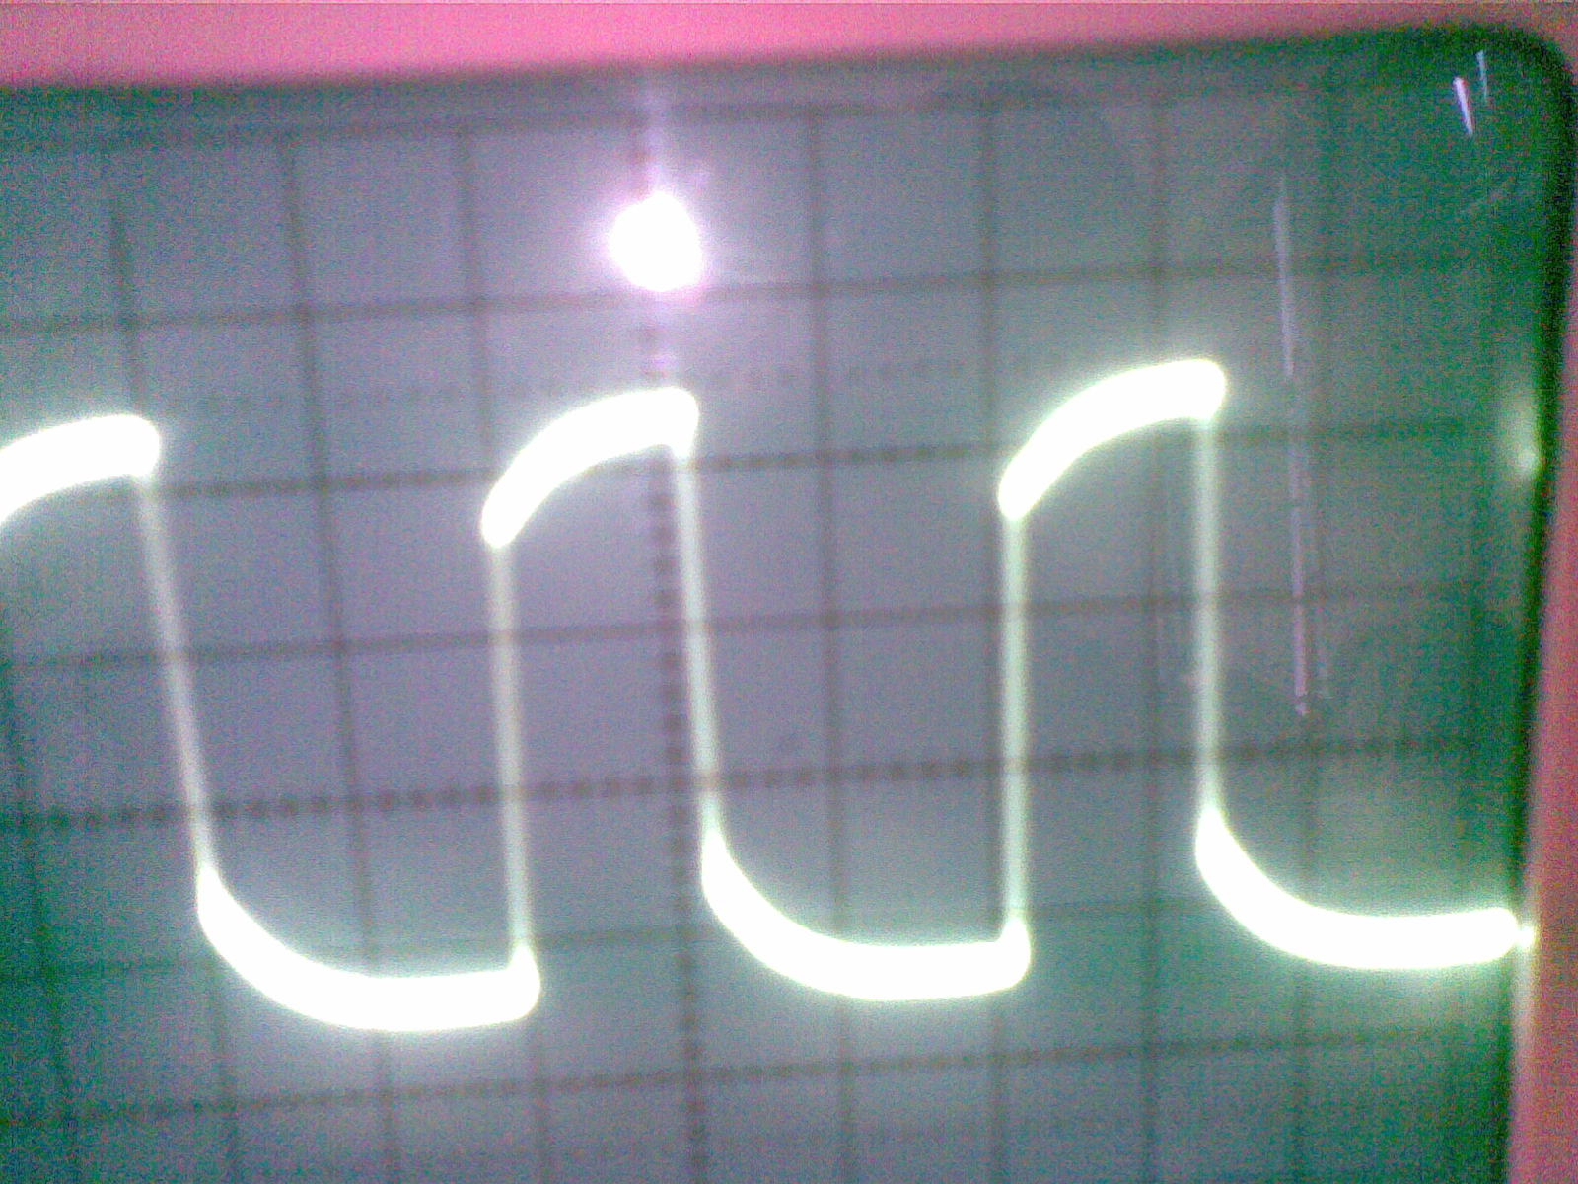

Minimum frequency plot

**Fill out the following values**

|  |  |  |
| --- | --- | --- |
|  | Maximum frequency of oscillation | Minimum frequency of oscillation |
| Theoretically calculated value | 267.54 Khz | 164.47 Hz |
| Obtained through simulation | 105.6Khz | 171.82Hz |
| Measured on practical realization | 142Khz | 156.25Hz |

**Fill out the following values**

|  |  |  |
| --- | --- | --- |
|  | Value of Vp (for Maximum frequency of oscillation) | Value of Vp (for Minimum frequency of oscillation) |
| Theoretically calculated value | 1.3V | 9.09V |
| Obtained through simulation | 2.305 V | 7.56 V |
| Measured on practical realization | 1.42V | 8.52V |

Lift R1 from ground to a potential of 5 Volts. Fill out the values below.

|  |  |
| --- | --- |
|  | Maximum frequency of oscillation |
| Theoretically calculated value | 216.5khz |
| Obtained through simulation | 86.5Khz |
| Measured on practical realization | 115khz |

**What happens to the astable action in case 3.5?**

Response is not symmetric , and frequency has decreased , Rise time is still the same.

### Conclusions

**What problems did you face in the design phase?**

The problem of finding the maximum and minimum frequency seems to the problem of optimization but the equation of time period of multivibrator has four independent variables that can assume different values.



We did tried to get some essence of the trend of curves in matlab by varying one of the variables and keeping the others fixed. This is the trend of variation of

Ln (2 (R1/R2) +1)

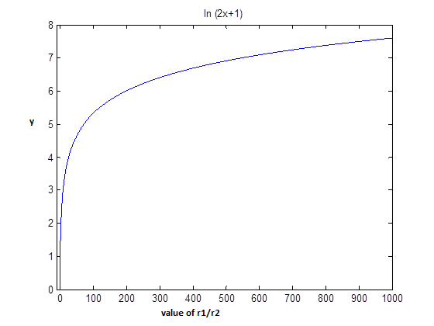

Picture taken from Matlab



Picture taken from matlab

As the values of ratio R1/R2 can’t take all values (because of restriction that only the components present in Student Learning Kit are to be used ), we decided to stop pondering on the exhaustive mathematical analysis of the equation and rather find the min/max values based on combinations of the resistors and capacitors present in the kit.

Other major problem is that the variables in the equation to be optimized has four different variables, which can assume a lot of different values based on series and parallel combinations, so there was a little problem in regard to the clarity of the problem itself. Later, we also studied the problem on the basis of some combinations and presented the results.

**What problems did you face during simulation?**

As illustrated by the data above, the results taken from simulations (for some particular configuration of the circuit) vary a lot from the theoretical values calculated using the theoretical time period formula of astable multivibrator. The same mismatch of results can be seen in simulation and practical results measured from oscilloscope.

**What problems did you face during practical implementation?**

During the circuit design to find minimum frequency, we tried to use the maximum value of capacitor 1F and the plots in the oscilloscope started flickering. This flickering effect was also observed in case of all values of capacitors greater than 1uF. This was due to the large value of time constant. So although the frequency might be very low for these values of capacitors but due to limitation of our oscilloscope we can’t calculate the frequency of oscillation of astable multivibrator. This is some of the pictures of this effect.

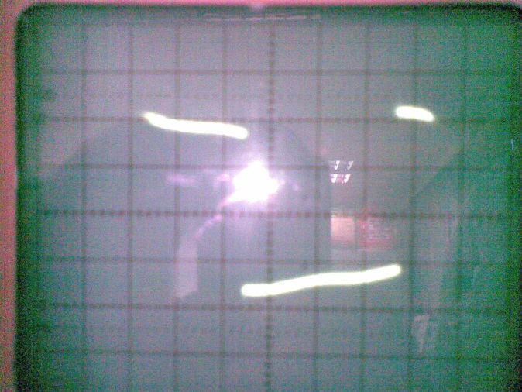 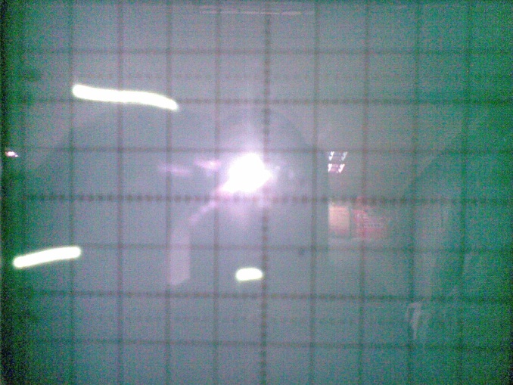

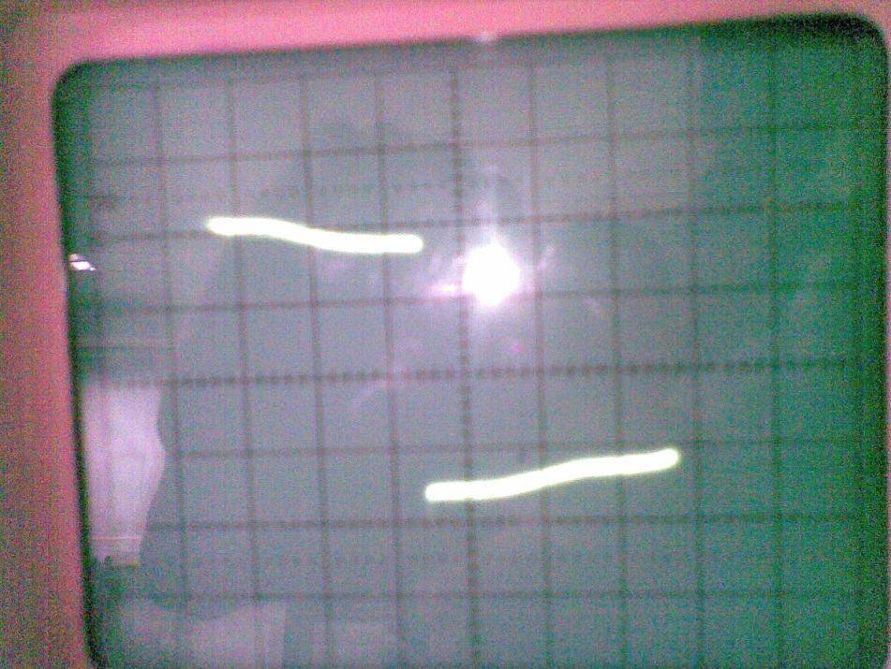

During the exploration of maximum frequency of multivibrator, we tried to use three capacitors(10 nF) in series to further get a low value of capacitance (3.3nF), but in this our results obtained practically deviated a lot from the simulated and theoretically calculated value of Vp and frequency and further the value obtained was not stable on the oscilloscope. After consultation with our mentor, we found that this is due to synchronization problem charging and discharging of capacitors. So due to this reason we did not used any capacitor networks for achieving extended values if capacitance, for more optimized results. However, obviously no such effect was found in resistor networks so we used them to get better optimized results.

3 c vp -

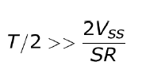

//Mobile pics of oscilloscope

**Summarize any new learnings.**

We have learnt a lot over a period of last two months about analog electronics and opamps. The problems framed are very sufficient both in the level of difficulty and research component. These problems helped a lot in clearing the concepts of ‘analog system design’ and ‘analog signal processing’. We hope to learn even more from the Texas analog design contest in the next phase and we are thankful to Texas for giving such a wonderful opportunity.

**************************************************************************

Rough work



